Link: http://gander.wustl.edu/~wilson/genechecker/index.html

(10 pts) Gene Model Checker:

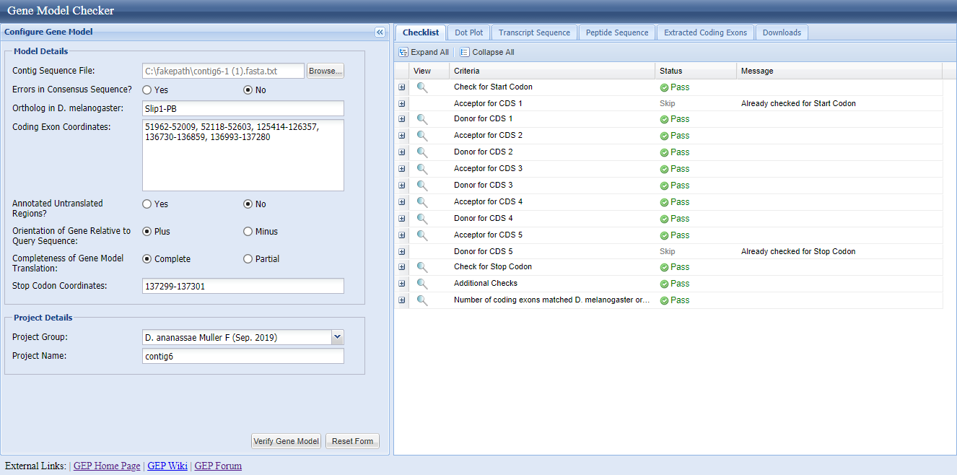

  - Explain any excused failures
- Acceptor for CDS 1(Skip) is an excused failure because the sequence region has been checked as part of the start codon. The Gene model checker skipped the check for acceptor site because it is the first coding exon and has already checked for the presence of the start codon.
ii. Donor for CDS 5(Skip) is an excused failure because the specific region of the sequence forms part already checked for the stop codon. The gene model checker skipped check for donor for CDS 5 because it is the donor in the last coding exon and has already been checked for stop codon.

(10 pts) Dot Plot
- Take a screen shot of your dot plot and paste it into your report.

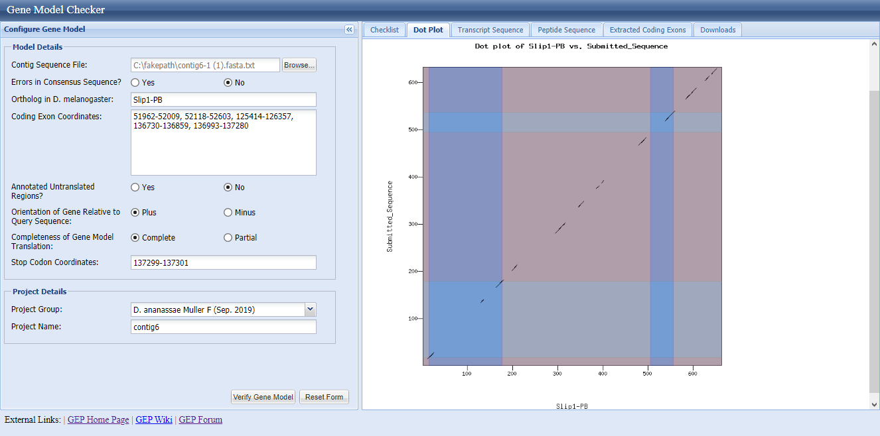

- Discuss any problems with your gene model that you have noticed from the dot plot.
Some of the problems identified are large gaps in the codon that increase the difference in the isoform from the original gene sequence. The dots in the plot dot shows similarity regions between the two sequences with slip1-PB along the x-axis and the submitted sequence on the Y-axis.

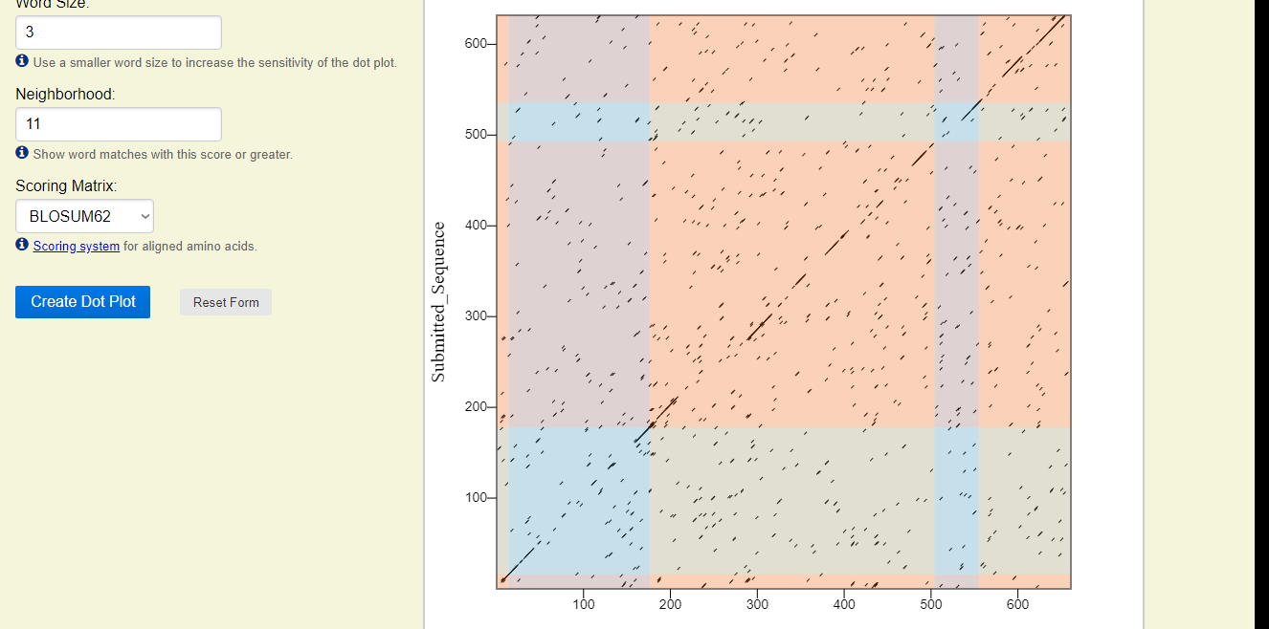

(10 pts) Protein Alignment
- take a screenshot of the sequence alignment. You may need to scroll down, and break it up into several screen shots to obtain the entire alignment.
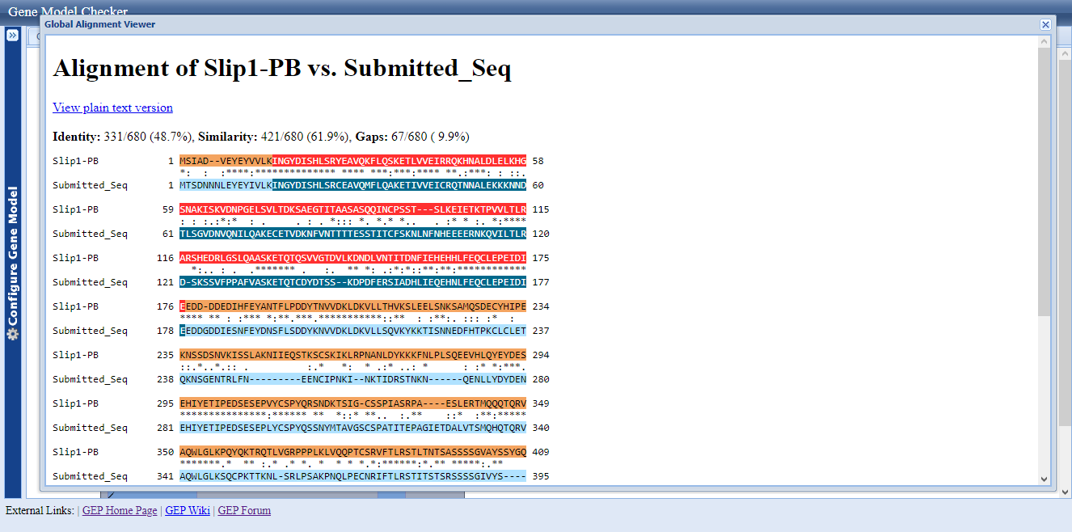

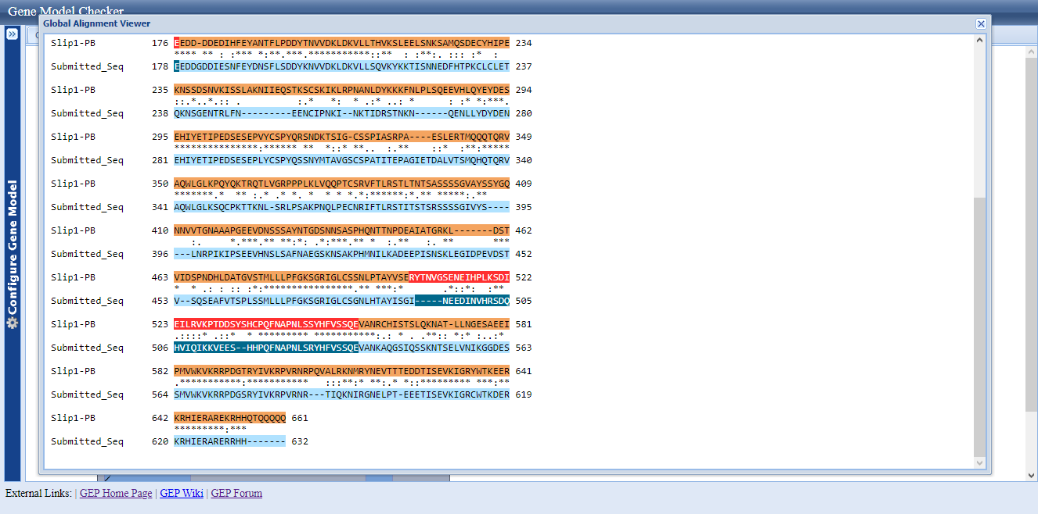

- does the overall length of your predicted sequence match well to the D. melanogaster
ortholog? Are there large gaps (-------) in the alignment? If there are gaps, do these gaps map to a boundary between exons or in the middle of the exon? What can this mean?
The overall length of the predicted sequence is 680 with a 61.9% similarity to the D. melanogaster ortholog; slip1-PB. The observation on the dot plot indicates that the protein at the beginning has a weak sequence similarly to the global alignment. There are large gaps in the internal part of the alignment after the blastx alignment of Slip1-Pb. The gap indicates a difference in the gene sequence of D. melanogaster and slip 1-PB. The observations mean that D. ananassae Muller F has few differential residues when compared to its D. melanogaster ortholog.
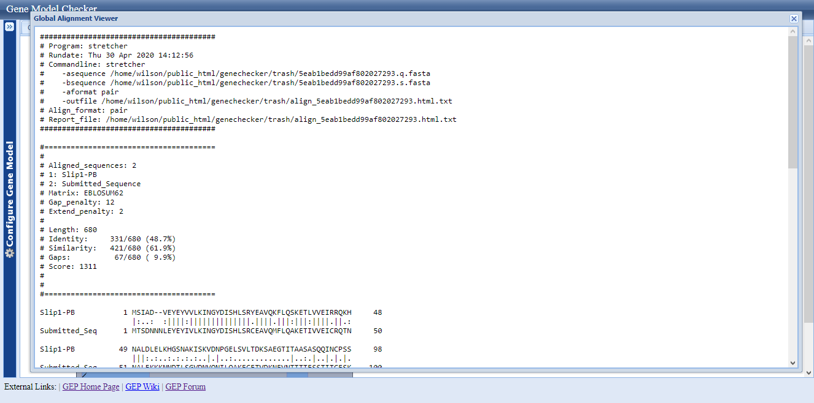

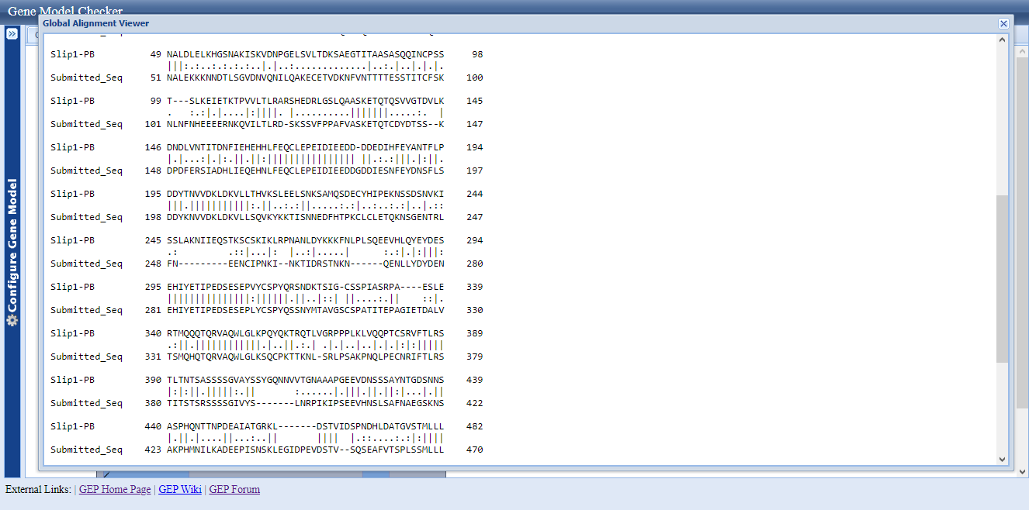

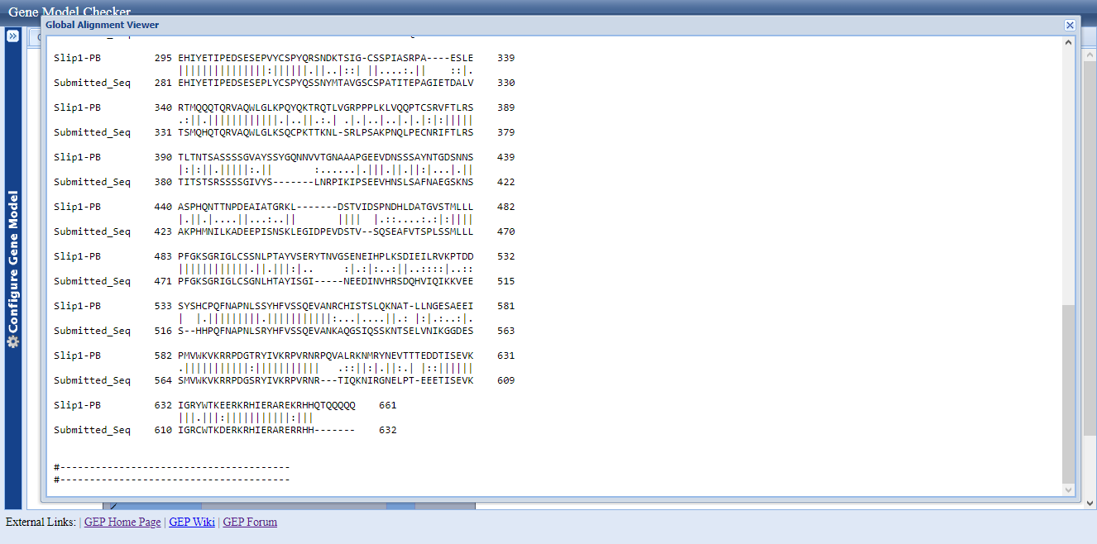

(10 pts) GEP UCSC Genome Browser verification

- Custom Gene Model
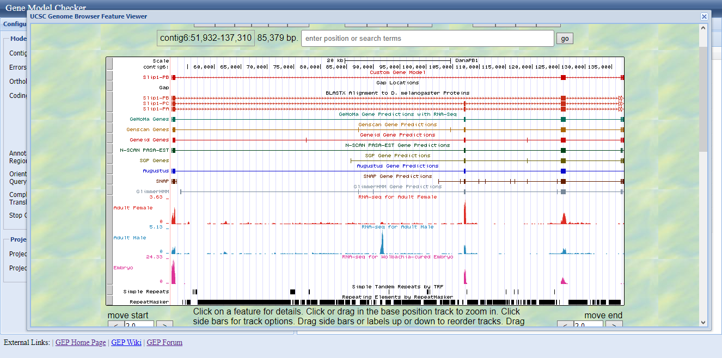
ii. Beginning of the gene

Start Codon
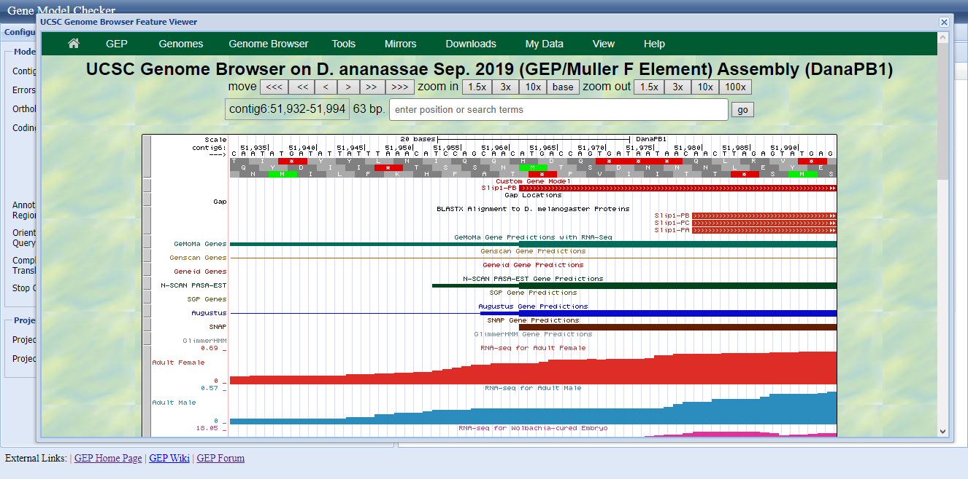
iii. End of Gene
End Codon
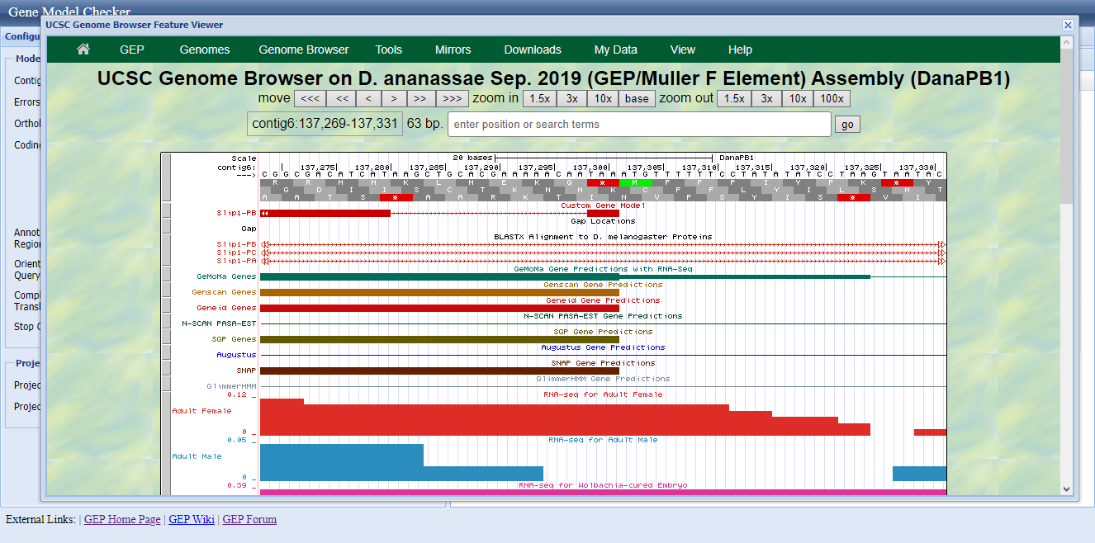

(10 pts) Conclusions
What do you conclude about your gene in terms of
    - Number of exons related to its orthologue in melanogaster
The gene had a high number of exons related to the orthologue in melanogaster as evident by the high similarity percentage. The few differences in the gene structure results from the dubious exon predictions, deleted introns and missed terminal exons. The number of N-terminal axons absent is higher than the C-terminal exons as the exonerate produce alignments that have allow all the exons to be represented.
    - The identity and similarity related to its orthologue in melanogaster
The identity of the gene in relation to the Dana is 478.7% while the similarity is at 6.9%. The identity and similarity shows that more than half or the parts in the gene sequence are identical to the DanaPB1.
    - Did the gene diverge from its orthologue in melanogaster?
The diverged from the DanaPB1, an orthologue in melanogaster as evident by the custom model alignment. The difference in repeat diversity and gene characteristics prove divergence from of DanaPB1 from the melanogaster.
    - How useful was the melanogaster gene model in figuring out the gene model for your isoform in the D. ananassae contig?
The melanogaster gene model provides a referencing point to modify the gene model for the isoform in D. ananassae contig6. The melanogaster reduces the complexity of the sequence which increases the analysis per nucleotide using the provided data. The model also reduces the repetitive elements per coding region.

